You are given an m x n integer array grid where grid[i][j] could be:

* 1 representing the starting square. There is exactly one starting square.
* 2 representing the ending square. There is exactly one ending square.
* 0 representing empty squares we can walk over.
* -1 representing obstacles that we cannot walk over.

Return *the number of 4-directional walks from the starting square to the ending square, that walk over every non-obstacle square exactly once*.

**Example 1:**

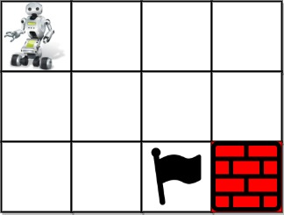

Input: grid = [[1,0,0,0],[0,0,0,0],[0,0,2,-1]]  
Output: 2  
Explanation: We have the following two paths:   
1. (0,0),(0,1),(0,2),(0,3),(1,3),(1,2),(1,1),(1,0),(2,0),(2,1),(2,2)  
2. (0,0),(1,0),(2,0),(2,1),(1,1),(0,1),(0,2),(0,3),(1,3),(1,2),(2,2)

**Example 2:**



Input: grid = [[1,0,0,0],[0,0,0,0],[0,0,0,2]]  
Output: 4  
Explanation: We have the following four paths:   
1. (0,0),(0,1),(0,2),(0,3),(1,3),(1,2),(1,1),(1,0),(2,0),(2,1),(2,2),(2,3)  
2. (0,0),(0,1),(1,1),(1,0),(2,0),(2,1),(2,2),(1,2),(0,2),(0,3),(1,3),(2,3)  
3. (0,0),(1,0),(2,0),(2,1),(2,2),(1,2),(1,1),(0,1),(0,2),(0,3),(1,3),(2,3)  
4. (0,0),(1,0),(2,0),(2,1),(1,1),(0,1),(0,2),(0,3),(1,3),(1,2),(2,2),(2,3)

**Example 3:**



Input: grid = [[0,1],[2,0]]  
Output: 0  
Explanation: There is no path that walks over every empty square exactly once.  
Note that the starting and ending square can be anywhere in the grid.

**Constraints:**

* m == grid.length
* n == grid[i].length
* 1 <= m, n <= 20
* 1 <= m * n <= 20
* -1 <= grid[i][j] <= 2
* There is exactly one starting cell and one ending cell.